Algorithmic tasks

Table of Contents
1 Stack 3
2 Binary Search 3
3 Insert in a sorted way 3
4 Preorder traversal 4
5 Design for card play 4
6 Choose Time Complexity 4
7 Count Time Complexity 4
8 Print all positive integer solutions 5
9 Find elements in 2 arrays 5
10 Check value of a binary number 5
11 Draw a circle 5
12 String permutation 5
13 Sorted merge 5
14 Largest subarray sum 5
15 kadane-algorithm Addition without + 6
16 Baby Names 6
17 Power of 2 6
18 Longest word 6
19 Detect and Remove Loop in a Linked List 6
20 Maximum Height of a Tree 7

Stack
Implement a stack in your language and justify your decision in comments. Design the interface to your stack to be complete, consistent, and easy to use.

Binary Search
Implement a function to perform a binary search on a sorted array of integers to find the index of a given integer. Use this or similar method declaration (dependent on your technology):
int binarySearch( int[] array, int lower, int upper, int target )

Insert in a sorted way
Given a sorted linked list and a value to insert, write a function to insert the value in sorted way.
Initial Linked List:
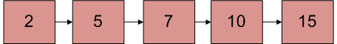
Linked List after insertion of 9:
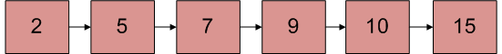

class LinkedList
{
Node head; // head of list

/* List Node*/
class Node
{
int data;
Node next;
Node(int d) {data = d; next = null; }
}

/* Insert a new node to the list*/
void sortedInsert(Node new_node)
{
/* Need to write this code */
}

/* Create a node */
Node newNode(int data)
{
Node x = new Node(data);
return x;
}
}

Preorder traversal
Informally, a preorder traversal involves walking around the tree in a counterclockwise manner starting at the root, sticking close to the edges, and printing out the nodes as you encounter them. For the tree shown in figure below, the result is 100, 50, 25, 75, 150, 125, 110, 175. Perform a preorder traversal of a binary search tree, printing the value of each node.
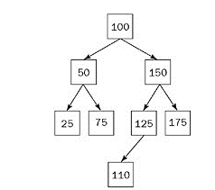

Design for card play
Design the data structures for a generic deck of cards. Explain how you would subclass the data structures to implement blackjack.

Choose Time Complexity
Which of the following are equivalent to O(N)? Why?
- O(N + P), where P < X
- 0(2N)
- O(N + log N)
- O(N + M)

Count Time Complexity
The following code sums the digits in a number. What is its big O time?
int sumDigits(int n) {
int sum = 0;
while (n > 0) {
sum += n % 10;
n /= 10;
}
return sum;
}

Print all positive integer solutions
Print all positive integer solutions to the equation a³ + b³ = c³ + d³ where a, b, c and d are integers between 1 and 1000. Use the most efficient way for this.

Find elements in 2 arrays
Given two sorted arrays, find the number of elements in common. The arrays are the same length
and each has all distinct elements. Do it with the most efficient way. You can either write code or describe the approach with the using of words (like pseudocode).

Check value of a binary number
Write a function to check if the value of a binary number (passed as a string) equals the hexadecimal representation of a string. It should be as elegant as possible.

Draw a circle
Write a routine to draw a circle (x ** 2 + y ** 2 = r ** 2) without making use of any floating point computations at all.

String permutation
Given two strings, write a method to decide if one is a permutation of the other.

Sorted merge
You are given two sorted arrays, A and B, where A has a large enough buffer at the end to hold B. Write a method to merge B into A in sorted order.

Largest subarray sum
Write an efficient program to find the sum of contiguous subarray within a one-dimensional array of numbers which has the largest sum.
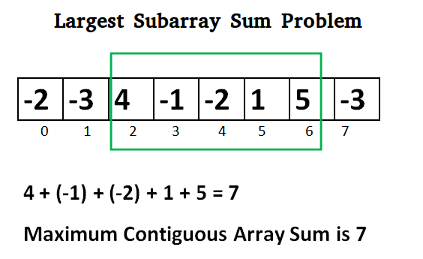

kadane-algorithm Addition without +
Write a function that adds two numbers. You should not use+ or any arithmetic operators.

Baby Names
Each year, the government releases a list of the 10000 most common baby names and their frequencies (the number of babies with that name). The only problem with this is that some names have multiple spellings. For example, "John" and ''.Jon" are essentially the same name but would be listed separately in the list. Given two lists, one of names/frequencies and the other of pairs of equivalent names, write an algorithm to print a new list of the true frequency of each name. Note that if John and Jon are synonyms, and Jon and Johnny are synonyms, then John and Johnny are synonyms. (It is both transitive and symmetric.) In the final list, any name can be used as the "real" name.
EXAMPLE
Input:
Names: John (15), Jon (12), Chris (13), Kris (4), Christopher (19)
Synonyms: (Jon, John), (John, Johnny), (Chris, Kris), (Chris, Christopher)
Output: John (27), Kris (36)

Power of 2
Write a function that checks if a given number is a power of 2.

Longest word
Given a list of words, write a program to find the longest word made of other words in the list.
EXAMPLE
lnput: cat, banana, dog, nana, walk, walker, dogwalker
Output: dogwalker

Detect and Remove Loop in a Linked List
Write a function detectAndRemoveLoop() that checks whether a given Linked List contains loop and if loop is present then removes the loop and returns true. And if the list doesn’t contain loop then returns false. Below diagram shows a linked list with a loop. detectAndRemoveLoop() must change the below list to 1->2->3->4->5->NULL. List class should be created by yourself.
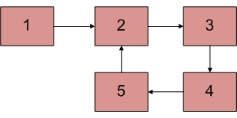

Maximum Height of a Tree
Given a binary tree, find height of it. Height of empty tree is 0 and height of below tree is 3. Tree Class should be created by yourself.
